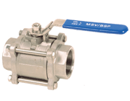 | MSV 3 PIECE STAINLESS STEEL 316  BALL VALVES  Fig 2013: 15% glass filled PTFE seats and seals, full bore,  SCRD BSP connections  in sizes 15mm to 100mm.
