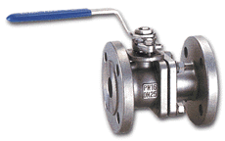 | 316 STAINLESS STEEL BODY AND BALL  Fig 2020: SS glass filled PTFE seats and seals, Full Bore, ASA150 & ASA300, lockable, Sizes 25mm to 150mm, larger sizes
