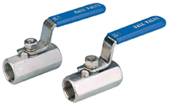 | MSV 1PC REDUCED BORE SCREWED  END BALL VALVES  Fig 2017: 316 stainless steel with 304 s/s handle, 15% glass filled PTFE seats and seals, 8mm to 32mm, 1000lb rating. 40mm and 50mm 800lb rating.
