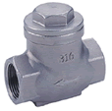 | STAINLESS STEEL SWING TYPE  Fig 2030: Stainless Steel Swing Type, Non-return valve, Female BSP, 200 PSI WOG. Sizes 15mm to 50mm.
