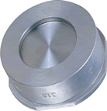 | STAINLESS STEEL DISC CHECK VALVE  Fig 2026: Spring loaded, Wafer Type, PN 40 Rated, to suit PN 40 Flanged. Sizes 15mm to 100mm
